TABLE OF CONTENTS

1. Introduction 3
1.1 Scope 3
1.2 Related Documents 3
2. Design Requirements and Constraints 4
2.1 External Requirements 4
2.2 Internal Requirements 4
2.3 Design issues 4
2.4 Real-Time Performance 4
3. PPP Entity Interfaces 4
3.1 Interface Flows 5
3.2 Data Structures 5
3.2.1 PFW_PLUGIN_OBJ_STATE 5
3.2.2 PFW_STACK_OBJ 6
3.2.3 M_BLK_ID 6
3.2.4 PPP_MESSAGE_TYPE_T 6
3.3 PPP-CSD Downlink Interface 7
3.3.1 NAT/IP -PPP Downlink Interface 7
3.3.2 CSD-PPP Uplink Interface 7
3.3.3 PPP-NAT/IP Uplink Interface 7
3.3.4 PPP-BSAP Interface 7
4. PPP Entity Design 8
4.1 Overview 8
4.2 Entity Functional Decomposition 9
4.2.1 PPP Initialization 9
4.2.2 PPP Call Back Functions 11
4.2.3 BSAP Control Interface Decomposition 12
4.2.4 PPP - CSD Downlink Decomposition 16
4.2.5 NAT/IP -PPP Downlink Decomposition 16
4.2.6 CSD-PPP Uplink Decomposition 16
4.2.7 PPP-NAT/IP Uplink Decomposition 17
5. Error Procedures 17
5.1 Stack Add Error Example 17
6. Unit Test Strategy 17
7. Additional Information 18
7.1 Resource Consumption 18
7.1.1 ROM 18
7.1.2 RAM 18
8. Open Issues 19
9. References 19
10. Acronyms 19
11. Review History 20

Introduction
This Software Description (SDS) specifies the detailed software composition for the PPP stack component entity residing in the WARP Software Architecture for release Venus. This entity is responsible for providing the link layer for IP-based CSD bearer over the GSM Abis channel between the WARP and MS. The information contained in this document shall be directly compliant with the C-GSM Release Venus Software Architecture Specification [3]. All references to the WARP and its software components will refer to the Venus release unless otherwise stated.

Scope
The PPP stack in Venus was purchased from WindRiver and is referred to as WindNet PPP by WindRiver. The PPP entity exists on each BPU and is responsible for providing multiple PPP sessions for IP-based CSD calls between the WARP and MS's. This document details how this third party PPP stack is integrated into our software architecture and the interfaces necessary for providing CSD bearer traffic between the WARP and MS. The WARP's PPP implementation must be compliant with IETF RFC-1661.

Related Documents
See Reference Section.

Design Requirements and Constraints

External Requirements
The WARP PPP stack must support the following features:
- PPP entity in WARP set to passive mode waiting for MS side to initiate a PPP session.
- Max PPP links matching max CSD calls (Maximum 60 simultaneous PPP sessions).
- Each PPP link must be uniquely identified so that it may be mapped to a CSD link/instance.
- The PPP stack sets up a unique access point for receiving MS-bound IP packets from a network source and associates this RX access point to the PPP link.
- The PPP link will remain established until the CSD call is ended. Upon call termination, the PPP link is released and the network source RX access point is closed.
- Provide external interfaces for Creating/Deleting stack instances and Establishing/Releasing PPP connections. These also include response interfaces from the PPP entity to the requesting entity.

Internal Requirements
When a PPP session is requested via the MS side, the PPP entity has the following responsibilities:
- Create and initialize a framework (framework is a collection of elements necessary to create PPP stacks. Multiple PPP session exist in one framework.)
- Create a Profile that stores the PPP session characteristics such as local and remote IP addresses etc.
- Open the PPP connection and return the stack instance to BSAP. This will uniquely identify the stack and allow BSAP to map between PPP and CSD link.
- LCP negotiation of the PPP session with the MS.
- PAP and CHAP authentication is TBD.
- Close the PPP connection upon BSAP request.

Design issues
The following design issues are TBD:
- Mobile Authentication (PAP, CHAP).
- IP address assignment.
- MRU Maximum Receive Unit Size.
- NAT interface.
- MIB library
See the Open Issues section for more information.

Real-Time Performance
The PPP entity spawns two tasks, a control task and data task. Control components such as LCP negotiation and PAP authentication run in the control task while data components such as the interfaces to the CSD IWF will reside in the data task. The priorities of these tasks are in the Bearer Priority subset.

PPP Entity Interfaces
The PPP Stack has interfaces with the following other entities:
- BSAP – This interface is provided by PPP for initializing and deleting PPP links.
- CSD IWF – This interface is provided by PPP for transfer of asynchronous characters to/from the CSD IWF.
- IP Stack – This interface is provided by PPP for transfer of IP packets to/from a network source.

Interface Flows
The following Diagram shows the interface flows through the PPP. The NAT is shown as a dotted entity because its interface is still TBD.

.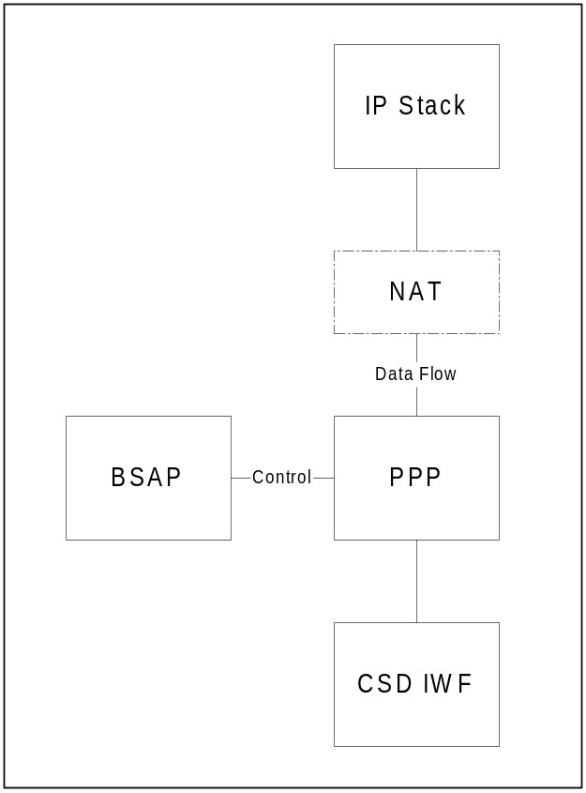
Figure 1: PPP interfaces

Data Structures

PFW_PLUGIN_OBJ_STATE
typedef struct pfwPluginObjState
{
PFW_PLUGIN_OBJ *pluginObj; /* pointer to the plugin object */
PFW_STACK_OBJ *stackObj; /* pointer to the stack object */
void *profileData; /* pointer to the profile data of the object */
void *stackData; /* pointer to the stack data of the object */
} PFW_PLUGIN_OBJ_STATE;

This is a global entity data structure that is used by the PPP entity to resolve the PPP stack instance that data is to be sent to or from. A pointer to this stack instance, referenced to in this structure, is used as a handle for each PPP instance.

PFW_STACK_OBJ
typedef struct pfwStackObj
{
unsigned int id; /* position in the stack table */
SEM_ID stackMutex; /* single thread access to stackObj */
PFW_OBJ * pfwObj; /* framework this belongs to */
PFW_STACK_STATUS status; /* current status of stack */
PFW_STACK_ITEM *
firstItem[PFW_LAYERED_PLANE_NUMBER];/*array of pointers to first receiving/
/* items in each layered plane */
/* traversed in this stack */
PFW_EVENT_ITEM *eventItemHead; /* head of the event item list */
PFW_STACK_OBJ_CALLBACKS *callbacks; /* callback functions for stack add */
/* delete processing */
void *userHandle; /* user provided handle */
PFW_LAYER_PROFILE_ITEM /* profile data */
*firstLayer[PFW_LAYERED_PLANE_NUMBER];
PFW_STACK_ITEM *lastAddedItem; /* the last added item in the add */
/* processes initiated by pfwStackAdd */

PFW_STACK_ITEM *lastDeletedItem; /* the last deleted item in the delete*/
/* processes initiated by pfwStackAdd */
} PFW_STACK_OBJ;

This is a global entity data structure that contains information concerning the current PPP stack instance. The void* userHandle parameter will be used to store off the CSD instance (MS Key provided from BSAP) that the PPP link is mapped to. This userHandle is made available to BSAP saving that entity from performing dynamic table lookups to find the PPP/CSD mapping.

M_BLK_ID
This structure contains the PPP packet payload as described in [7].

PPP_MESSAGE_TYPE_T
PPP will send confirmation of services requested via inter-task messaging to BSAP. These are the possible message types sent. More message types will be created as necessary.

typedef enum _PPP_MESSAGE_TYPE_T
{
PPP_STACK_ADD_SUCCESS, /* Stack Add Success Message Type */
PPP_STACK_ADD_FAILURE, /* Stack Add Failure Message Type */
PPP_STACK_DELETE_SUCCESS, /* Stack Delete Success Message Type */
PPP_STACK_DELETE_FAILURE, /* Stack Delete Failure Message Type */
PPP_CONNECTION_OPEN_SUCCESS, /* PPP Session Open Message Type */
PPP_CONNECTION_CLOSED_SUCCESS /* PPP Session Closed Message Type */
} PPP_MESSAGE_TYPE_T

PPP-CSD Downlink Interface
When the PPP stack has data to send to the MS, it will invoke the muxAdptrSend() routine. The CSD IWF code will be added to this routine and follows the procedure described in [4].

STATUS muxAdptrSend
(
PFW_PLUGIN_OBJ_STATE * pComponentState, /* our state for this stack */
M_BLK_ID * pMblkId /* packet to send */
)
This function returns OK or ERROR .

NAT/IP -PPP Downlink Interface
This interface is TBD.

CSD-PPP Uplink Interface
The CSD IWF will invoke pfwRecieve() to send this datagram up the PPP stack as referenced in [4].

STATUS pfwReceive
(
PFW_PLUGIN_OBJ_STATE * state, /* pointer to the state of the requester */
M_BLK_ID packet /* pointer to the packet */
)
This function returns OK or ERROR .

PPP-NAT/IP Uplink Interface
This interface is TBD.

PPP-BSAP Interface
The interface between BSAP and the PPP entity is a control interface. BSAP is responsible for indicating to the PPP when a PPP session is to be created or deleted and pass the userHandle (CSD instance). The PPP entity is responsible for providing to the BSAP a PPP stack instance at creation that can be used to map PPP session to CSD instance. Most of BSAP requests to PPP will be responded to via an inter-task message indicating the result.

SINT32_T EG_ PPPStackCreate(UINT32_T * userHandle )
BSAP will call EG_PPPStackCreate() when requesting a PPP stack instance and pass in the userHandle. The PPP entity will return SUCCESS or ERROR to the calling entity. A successful return from a call to this function does not indicate a stack has been created. An inter-task message will indicate success or failure.

SINT32_T EG_ PPPStackDelete( PFW_PLUGIN_OBJ_STATE * pppState)
BSAP will call EG_PPPStackDelete() and pass in the pppState pointer containing the stack instance to delete. The PPP entity will return SUCCESS or ERROR to the calling entity. An inter-task message will indicate success or failure.

SINT32_T EG_PPPConnectionOpen(PFW_PLUGIN_OBJ_STATE * pppState)
BSAP will call EG_PPPConnectionOpen() when a PPP connection is to be opened and pass in the pppState pointer containing the stack instance. The PPP entity will return SUCCESS or ERROR to the calling entity. An inter-task message will indicate success or failure.

SINT32_T EG_PPPConnectionClose(PFW_PLUGIN_OBJ_STATE * pppState)
BSAP will call EG_PPPConnectionClose() when a PPP connection is to be closed and pass in the pppState pointer containing the stack instance. The PPP entity will return SUCCESS or ERROR to the calling entity. An inter-task message will indicate success or failure.

UINT32_T* EG_PPPGetUserHandle(PFW_PLUGIN_OBJ_STATE * pppState)
This is a utility function intended for BSAP to resolve the user handle that stores the CSD instance (MS Key). The user handle will be returned to the calling entity.

PPP Entity Design

Overview
The design philosophy for the PPP entity is to successfully integrate the out of box PPP stack purchased from WindRiver into the Venus and future WARP architectures. The design should be such that a new PPP stack could be inserted with minimal changes to the defined interfaces.

Entity Functional Decomposition

PPP Initialization
The following steps show how a framework is created, and how components and layers are added to that framework to support a PPP stack.

Framework Creation
The first step in creating a PPP connection is to create a framework instance, by calling pfwCreate( ). Only one framework is necessary to hold many PPP sessions. This routine, pfwCreate(), creates and initializes a protocol framework object.

PFW_OBJ *pfwCreate
(
char * name, /* name of the framework object */
unsigned int controlJobQueueSize, /* size of control job queue in bytes */
unsigned int dataJobQueueSize, /* size of data job queue in bytes */
unsigned int controlTaskPriority, /* priority of the control task */
unsigned int dataTaskPriority, /* priority of the data task priority */
NET_POOL_ID netPoolId, /* id of the framework network pool */
PART_ID partId /* id of the framework memory partition */
)
This function returns a pointer to the created framework object, or NULL if the object can not be created.

#define PPP_CONTROL_QUEUE_SZ 100000
#define PPP_DATA_QUEUE_SZ 100000
#define VOICEBEAR_PRI_18
#define VOICEBEAR_PRI_19

PFW_OBJ * pppFramework

pppFramework = pfwCreate
(
PPP_SYSTEM_FRAMEWORK, /* name of the framework object */
PPP_CONTROL_QUEUE_SZ, /* size of control job queue in bytes */
PPP_DATA_QUEUE_SZ, /* size of data job queue in bytes */
VOICEBEAR_PRI_18, /* priority of the control task */
VOICEBEAR_PRI_19, /* priority of the data task priority */
PPP_NET_POOL_ID, /* the framework network pool */
PPP_MEM_PART_ID /* the framework memory partition */
)

Adding Plug in Objects
A PPP stack consists of layers and components, each implemented as a plug-in object as described in [1]. The PPP-related plug-in objects that are incorporated into the PPP Entity are shown in Figure 2. Refer to [1] for a better understanding of how to install plug in objects.

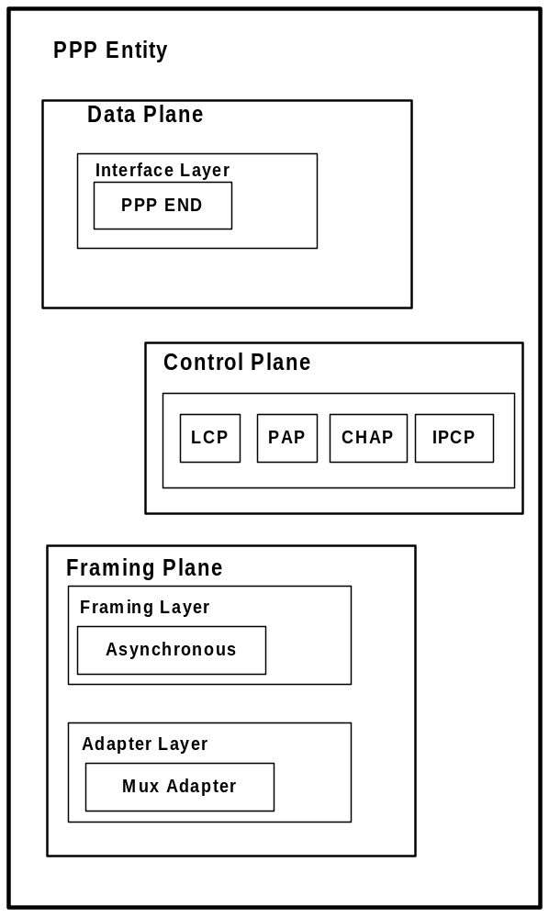
Figure 2: PPP Plug in Objects

MIB2 Library
This MIB2 library is used to maintain a managed object database. It is still TBD if we will use the MIB2 database to access information about PPP links. This database is responsible for such things as storing local and peer passwords for authentication.

Profile Initialization
Once the framework is created and the layers and components have all been included, a profile is created to describe the PPP session. This procedure is described in [1]. A base profile will be created that will be static throughout all PPP session but parameters such as local and peer assigned IP addresses will be unique for each PPP session. It is TBD what parameters will be unique for each PPP link and the IP assignment procedure is still TBD.

PPP Call Back Functions

Stack Creation Callbacks
These are the callbacks that are associated with pfwStackAdd() and will be used to indicate to BSAP if a stack was successfully created/deleted or an error has occurred. Ex: BSAP calls the wrapper function EG_PPPStackCreate() and the stackAddCompleteCallback will send an inter-task message to BSAP indicating a stack was successfully created.

PFW_STACK_OBJ_CALLBACKS pppCallbacks =
{
stackAddCompleteCallback,
stackDelCompleteCallback,
stackAddErrorCallback,
stackDelErrorCallback
};

PPP Connection Callbacks
These are the callbacks associated with pppConnectionOpen(). These callbacks will be used to inform BSAP when a PPP session has been established between the WARP and MS or when a PPP session has been closed. Ex: BSAP calls the wrapper function EG_PPPConnectionOpen() and the pppOpened callback will send an inter-task message to BSAP indicating a PPP session has been opened.

PPP_UPCALL_FUNCTIONS pppConnectionUpcalls =
{
pppOpenCompleteCallback,
pppCloseCompleteCallback
};

BSAP Control Interface Decomposition
In release Venus, multiple PPP sessions may exist between the WARP and MS. As mentioned previously, BSAP is responsible for indicating to the PPP when a CSD call has been requested and a PPP session is to be created. The PPP entity is then responsible for providing to the BSAP a PPP stack instance at creation that can be used to map PPP session to CSD call.

EG_ PPPStackCreate( )
BSAP will call EG_PPPStackCreate() to create a stack and pass in a userHandle. The userHandle is BSAP's method for maintaining the CSD instance. The PPP entity is responsible for returning a pointer to the PFW_PLUGIN_OBJ_STATE object. To do this the PPP will first create a stack instance.

Stack Creation
Create and initialize a new stack, and add it to the framework by calling pfwStackAdd().

PFW_STACK_OBJ * pfwStackAdd
(
PFW_PROFILE_OBJ * proObj, /* stack profile */
PFW_STACK_OBJ_CALLBACKS * callbacks, /* callback functions */
void * userHandle /* user provided handle */
)
Parameters
* proObj Stack profile created in Initialization section.
* callbacks Stack creation callback functions.
* userHandle This variable is used to store the userHandle passed in by BSAP.

This routine creates and initializes a new stack object using the given profile, and adds it to the framework. A pointer to the new stack object, or NULL if a new stack cannot be created is returned. The caller of this routine is notified when the stack is successfully added or failed using the given callback functions.

StackAddCompleteCallBack()
This callback routine is executed when a stack has been successfully added.

VOID_T stackAddCompleteCallback
(
VOID_T * handle,
PFW_STACK_OBJ * stackObj
)

Inside this callback routine an inter-task message is sent to BSAP indicating that a stack creation was successful. The message will also contain the pointer to the PFW_PLUGIN_OBJ_STATE object that contains the PPP stack instance to CSD call mapping. Because the callback routine receives the PFW_STACK_OBJ object, it must resolve the PFW_PLUGIN_OBJ_STATE object to send to BSAP. It accomplishes this through the following procedure.

Retrieve Mux Plugin Object
Get a pointer to the MUX ADAPTER plug-in object necessary for resolving the object state.
PFW_PLUGIN_OBJ * pMuxPlugin;

PFW_PLUGIN_OBJ * pfwPluginObjGet
(
PFW_OBJ * pfwObj, /* framework object */
char * name /* name of the plugin object to be returned */
)
pMuxPlugin = pfwPluginObjGet( pppFramework, "MUX_ADAPTER");

Retrieve the Plugin Object State
Get the state of a MUX ADAPTER plug-in object and return the pointer to BSAP.
PFW_PLUGIN_OBJ_STATE * pMuxCsdState;

PFW_PLUGIN_OBJ_STATE *pfwPluginObjStateGet
(
PFW_STACK_OBJ * stackObj,
PFW_PLUGIN_OBJ * pluginObj
)

pMuxCsdState = pfwPluginObjStateGet( stackObj, pMuxPlugin);

The PPP entity then sends an inter-task message to BSAP indicating PPP_STACK_ADD_SUCCESS and containing a pointer to the PFW_PLUGIN_OBJ_STATE object.

StackAddErrCallBack()

VOID_T stackAddErrorCallback
(
VOID_T * handle,
PFW_STACK_OBJ * stackObj
)

The PPP entity will send an inter-task message to BSAP indicating a PPP_STACK_ADD_FAILURE and return the handle. ERR_TRAK is used to capture the error.

EG_ PPPStackDelete()
BSAP will call EG_PPPStackDelete() and pass in the PFW_PLUGIN_OBJ_STATE containing the stack instance to delete. PPP will then delete the stack instance by calling pfwStackDelete().

STATUS pfwStackDelete
(
PFW_STACK_OBJ * stackObj /* stack to delete */
)

PFW_PLUGIN_OBJ_STATE * pMuxCsdState;
STATUS retVal;
retVal = pfwStackDelete(pMuxCsdState->stackObj);

The caller of this routine is notified when the stack is successfully deleted or failed to delete using the given callback functions

StackDelCompleteCallback()
This callback is invoked when the stack delete processing for the object has been completed.

VOID_T stackDelCompleteCallback
(
VOID_T * handle,
PFW_STACK_OBJ * stackObj
)

The PPP entity will return the handle to BSAP via an inter-task message. The message also indicates it is a PPP_STACK_DELETE_SUCCESS message.

StackDelErrorCallback()
The PPP entity will send an inter-task message to BSAP indicating a PPP_STACK_DELETE_FAILURE and return the handle. ERR_TRAK is used to capture the error.

EG_PPPConnectionOpen()
BSAP will call this function when a PPP connection is to be opened. The BSAP entity will pass in the PFW_PLUGIN_OBJ_STATE object on which to open the connection. PPP will make a call to pppConnectionOpen(), passing in the stack instance in which to open a connection and provide a pointer to the callback functions previously described.

STATUS pppConnectionOpen
(
PFW_STACK_OBJ * stackObj, /* stack on which to open connection */
PPP_UPCALL_FUNCTIONS * upcalls, /* upcall interface provided by user */
void * userHandle /* user cookie for this connection */
)
One thing to note is a successful return from a call to this function does not indicate an opened connection. The link must successfully perform its LCP negotiation before a link can be considered open and its corresponding callback will be invoked.

pppOpenCompleteCallback ()
The pppOpenCompleteCallback() callback is used to notify the application of an opened PPP connection.

VOID_T pppOpenCompleteCallback
(
VOID_T * handle,
PFW_STACK_OBJ * stackObj
)

The PPP entity will return the handle via an inter-task message. The message also indicates it is a PPP_CONNECTION_OPEN_SUCCESS message.

EG_PPPConnectionClose()
BSAP will call this function when a PPP connection is to be closed. The BSAP entity will pass in the PFW_PLUGIN_OBJ_STATE object on which to close the connection. PPP will make a call to pppConnectionClose(), passing in the stack instance in which to close a connection on.

pppCloseCompleteCallback()
The pppCloseCompleteCallback() callback will be called to indicate that the connection has been closed.

VOID_T pppCloseCompleteCallback
(
VOID_T * handle,
PFW_STACK_OBJ * stackObj
)
The PPP entity will return the handle via an inter-task message. The message also indicates it is a PPP_CONNECTION_CLOSED_SUCCESS message.

EG_PPPGetUserHandle()
This is a utility function intended for BSAP to resolve the user handle that stores the CSD instance. This method of storing off the CSD call instance in the handle is better than having BSAP store it in a table and have to perform a table lookup any time it needs the mapping value. The user handle is contained inside the PFW_STACK_OBJ structure and is a void*. This function will probably be changed to a macro later.

Return (UINT32_T) (pppState->stackObj->userhandle);

PPP - BSAP Inter Task Message
The SIGNAL_T structure is the System-Standard Inter-Task Data Communication Structure. It is required for all inter-task data communication as described in [6]. The PPP populates the SIGNAL_T structure as follows:

SIGNAL_T msg /* Structure containing the data to be sent */

msg.srcTask = TASK_PPP;
msg.dstTask = TASK_BSAP;
msg.msgId = PPP_MESSAGE_TYPE_T;
msg.msgBuf = PFW_PLUGIN_OBJ_STATE or handle;

PPP will call EG_OsTaskMsgSend(&msg) to send the message to BSAP. The message type will be stored in msgId and the msgBuf will contain the pointer to the PFW_PLUGIN_OBJ_STATE object in the case of EG_PPPStackCreate() or the userHandle in all other cases. In the case of an ERROR the msgId should reflect the type of error. BSAP is then responsible for taking the appropriate actions.

PPP - CSD Downlink Decomposition
The adapter layer is the bottom layer of the PPP stack. Inside this layer the MUX adapter is used to allow PPP to communicate through MUX-aware network drivers (ENDs and NPT-drivers). The MUX is described in [2]. This is the location that the PPP data is hooked into the CSD IWF. When the PPP stack has data to send to the MS, it will invoke the muxAdptrSend() routine. The CSD IWF code will be added to this routine and follows the procedure described in [4].

STATUS muxAdptrSend
(
PFW_PLUGIN_OBJ_STATE * pComponentState, /* our state for this stack */
M_BLK_ID * pMblkId /* packet to send */
)
This function returns OK or ERROR .

NAT/IP -PPP Downlink Decomposition
This interface is TBD.

CSD-PPP Uplink Decomposition
After obtaining data from the CSD Stack and getting the PPP link identifier via BSAP interface, the CSD IWF should repackage the datagram into a Mblk structure. The CSD IWF will invoke pfwRecieve() to send this datagram up the PPP stack as referenced in [4].

STATUS pfwReceive
(
PFW_PLUGIN_OBJ_STATE * state, /* pointer to the state of the requester */
M_BLK_ID packet /* pointer to the packet */
)
This function returns OK or ERROR .

PPP-NAT/IP Uplink Decomposition
This interface is TBD

Error Procedures
The PPP entity will report internal errors via the ERR_TRAK mechanism. The PPP entity will not have any error recovery functionality and will leave this functionality to the entity requesting its service. The PPP entity will simply report errors. For example, the PPP entity will return errors to BSAP via an inter-task message.

Stack Add Error Example
BSAP will call EG_PPPStackCreate() and pass in the CSD instance to the PPP entity. The PPP entity will return to BSAP SUCCESS that this request is now being serviced. If during the course of servicing the stack add request an error occurs, the stackAddErrorCallback() will be invoked. In this callback an inter-task message will be sent to BSAP indicating the error.

VOID_T stackAddErrorCallback
(
VOID_T * handle,
PFW_STACK_OBJ * stackObj
)
{
SIGNAL_T msgPtr /* Structure containing the data to be sent */
MsgPtr.srcTask = TASK_PPP;
MsgPtr.dstTask; = TASK_BSAP;
MsgPtr.msgId = PPP_STACK_ADD_FAILURE ;
MsgPtr.msgBuf = handle;

ERR_TRAK(TASK_PPP, ERR_TRAK_ERROR, ("Stack Create has failed \n"), NULL);
EG_OsTaskMsgSend(msgPtr);

}

Unit Test Strategy
Please refer to the PPP section in [8] for a full unit test strategy.

Additional Information

Resource Consumption
The framework that is created should be large enough to hold all the PPP stacks. In release Venus it is determined that 60 CSD calls will be required so the framework queue sizes will be based on that design parameter. The MRU configuration option is negotiable between the WARP and MS and it is TBD what the mobile will want to negotiate the MRU to. The default value is 1500 octets. The control and data queue sizes are determined as follows:
Data Queue size = (Max Number of CSD calls) * (MRU)
Data Queue size = 60 * 1500
Data Queue size = 90,000 bytes or approx. 100kBytes.

This approximation is probably much higher than is necessary and will probably be tweaked at a later date. (TBD).

Open Issues
Id | Issue | Current Assumptions and Plans
 | What kind of authentication will the mobile negotiate. | It is assumed that if a phone is registered to have CSD access the user should not need to put in a password that is authenticated through PPP. The plan is to bypass the password authentication by allowing any password to work.
 | IP address assignment | It is currently assumed that the BSAP entity will provide the PPP address to assign to the MS for each PPP session.
 | MRU size | Have not been able to determine what the MRU is for CSD. Currently the PPP MRU is set to 1500.
 | MIB library | Currently the MIB is used to store passwords and its use will be affected by 1.
5. | PPP Connection Callbacks. | Currently there are not any callbacks to indicate that a PPP session failed to open or close. BSAP will need to know if these error cases occur. BSAP may be able to implement a timer to indicate a non-success upon expiry.

References
[1] WindRiver, WindNetPPP Programmers Guide 1.0, Edition 1, April 13/2000 Doc 13252-ND-01
[2] WindRiver, VxWorks Network Protocol Toolkit Programmer’s Guide
[3] Opuswave, “Software Architecture Specification, Wireless Adjunct Internet Platform”, Doc 27300185.
[4] Opuswave, "Specification, Circuit Switched Data Interworking Function Software Design, C-GSM Release 2", Doc. 27300280
[5] Opuswave, "WARP BSAP/BSAP-M Interface & Usage", Doc 27300287
[6] Opuswave, "OSAL Users Guide Rel2", Doc ???
[7] WindRiver, VxWorks Network Programmer's Guide, 5.4, March 22/1999 Doc-12779-ZD-01
[8] Opuswave, "BEARER DITP, C-GSM PROJECT VENUS", Doc 27400420
[9] Network Working Group, "Request for Comments: 1661", July 1994 STD:51
[10] Opuswave, "Specification, WAP over Non-Transparent CSD, Bullet Office Release 2", Doc 27300126.

Acronyms
AIU | Abis Inter-working Unit
BPU | Bearer Processing Unit
BSAP Bearer Service Access Point
C-GSM | Corporate GSM
CHAP Challenge Authentication Protocol
CSD | Circuit Switched Data
GSM | Global System for Mobile (Groupe Spécial Mobile)
IP Internet Protocol
IWF | Inter-Working-Function
LCP Link Control Protocol
MRU Maximum Receive Unit
MS | Mobile Station (MS1 = Mobile Station 1, MS2 = Mobile Station 2, etc.)
OSAL | Operating System Abstraction Layer
PAP Password Authentication Protocol
PPP Point to Point Protocol
TBD | To Be Determined
WARP | Wireless Adjunct inteRnet Platform
WAP Wireless Access Protocol

Review History
For each reviewed version of this document add a new page to this appendix containing a duplicate of the following table and record the review meeting information for that version.
The Release Version Number field should only be filled out if the completion of the review of a preliminary version of the document resulted in the release of the document.
The Additional Approval Routing List field should only be filled out if it was determined during the review meeting that other individuals in addition to the Moderator need to approval the final version of the document prior to its release.

Reviewed Version Number: | P1A
Review Date: | 3 May 2001
Review Moderator: | T. Douglas
Critical Reviewers: | E. Ogren, R. Myers, C. Craddock, A. Kreft
Secondary Reviewers: | None
Review Approval Status: | Approved As Is: _____  Approved With Comments: __X__  Re-review Required: _____
Number of Pages Reviewed: | 17
Length of Review Meeting: | 60 minutes
Released Version Number: | 00A
Additional Approval Routing List: | None

